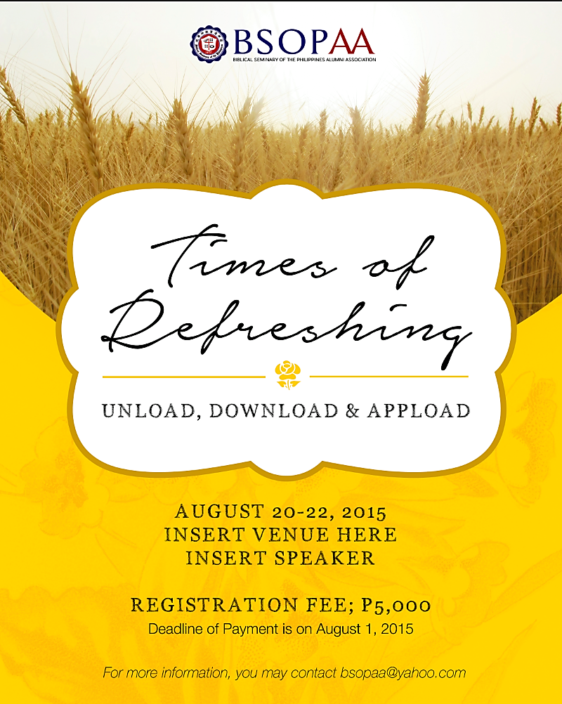
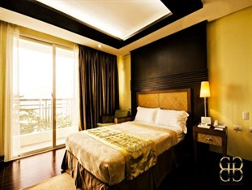
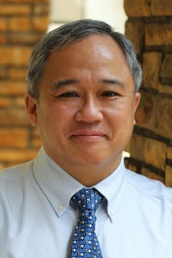

DATE: August 20 – 22, 2015

SPEAKER: Rev. Danny Reyes

Come and Join us! Open to all BSOP Alumni and their family members.

PLACE: Subic Grand Harbour Hotel

249 Waterfront Road
Subic Bay Freeport Zone

REGISTRATION FORM

Name: ___________________________________________________________________
Chinese Name: ________________________________________________________________
Age: __________________ Date of Birth: (M/D/Y) ___________________________________
Gender: ____M ____F Civil Status: ____ Single _____Married _____Widowed
Address:_____________________________________________________________________________________________________________________________________________________
Church/Organization: ____________________________________________________________
Position: ______________________________________________________________________
Telephone Number: ________________________ Fax Number: ________________________
Mobile Number: _______________________________________________________________
Email Address: _________________________________________________________________
Please indicate if you have any health issues (allergies or medication). ______________________________________________________________________________
Name and telephone number of contact person in case of emergency. ______________________________________________________________________________

REGISTRATION FEES
The Registration Fee covers 3 days and two nights stay inclusive of meals, snacks, and free use of facilities. Discount of less Php300.00/adult pax for those who register on or before July 27, 2015. You can deposit your payment to BSOP AA bank account under the name of Wilson C. Wong Gonzales or Catherine Tan or Mary Ann Wong, BDO Masangkay – Luzon Sts., account number 004320035197. Please email attach the deposit slip to maryann_wng@yahoo.com.

For Quapdruple sharing room: 2,800/pax or 2,500/pax on or before July 27, 2015
For Triple sharing room: 3,600/pax or 3,300/pax on or before July 27, 2015
For Twin sharing room: 5,200/pax or 4,900/pax on or before July 27, 2015

Children 8 - 12 years old will be charge 50% off with the corresponding room rates as follows:
For Quadruple- 1,400/pax
For Triple- 1,800/pax
For Twin- 2,600/pax
Children 7 years old and below will be free of charge but beds will not be provided.

NAME | AGE | AMOUNT
TOTAL AMOUNT:

I have understood the terms and conditions of this Retreat and will not hold BSOP or the BSOP AA liable for any loss or injury that may occur during the Retreat. I will fully comply with the rules and regulations of the retreat organized by BSOP AA.

_________________________________________
Signature
_________________________________________
Date

